https://www.maketecheasier.com/delete-personal-data-from-internet/:
How to Delete Your Personal Data from the Internet

Sharing your personal data on the Web is never a difficult task. Simply sign up for a Facebook account (or any other social networks) and fill in your personal details, all your personal info will be instantly available for everyone to see. What is more difficult though, is getting your personal data off the Web. If you have no use for any account in the Internet, it is always a good idea to delete your information so they are not accessible by others. In this article, we will show you how to delete your personal data from various popular sites and services on the Internet.

Facebook
Facebook is the most popular social network. Millions of people are using Facebook to share their personal information. If you are no longer using your Facebook account, it is possible to delete the account along with your data.
There is one catch though, not all data will be deleted. Things like group messages and other collaborative data will not be deleted as stated in Facebook terms and conditions.
To delete your Facebook account, follow the steps below:
1. Go to this link
2. Press the “Delete My Account” button
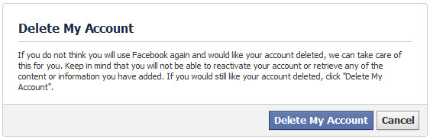<img class="aligncenter size-full wp-image-81279" alt="del_facebook" src="https://www.maketecheasier.com/assets/uploads/2013/09/del_facebook.jpg" />
3. Enter your password and the security code
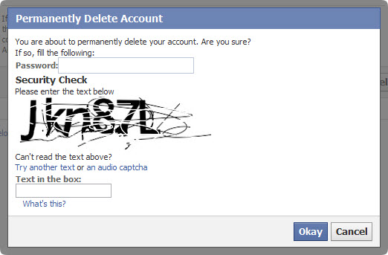<img class="aligncenter size-full wp-image-81277" alt="del_facebook 1" src="https://www.maketecheasier.com/assets/uploads/2013/09/del_facebook-1.jpg" />
4. Your account will be disabled immediately.
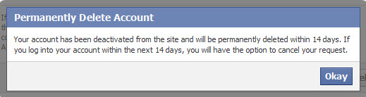<img class="aligncenter size-full wp-image-81278" alt="del_facebook 2" src="https://www.maketecheasier.com/assets/uploads/2013/09/del_facebook-2.jpg" />
Please note that this will be a soft delete, meaning that if you login to your Facebook account again within the next 14 days, there will be an option for you to cancel your request.

Google
Google offers many services which can save our personal data on Google’s servers. Fortunately, Google provides a mean for us to delete our Google account along with all the data. Be careful though, as this means that all your emails (in Gmail), documents (in Google Drive), Contacts, Calendar etc will be gone the moment your account is deleted. The only exception is your Google+ profile, which you can delete without deleting other Google services.
To delete a Google account, follow the steps below:
1. Go to this link
2. Under account management, click “Close account and delete all services and information associated with it.” link
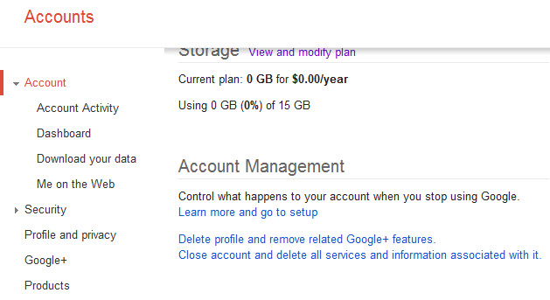<img class="aligncenter size-full wp-image-81282" alt="del_google" src="https://www.maketecheasier.com/assets/uploads/2013/09/del_google.jpg" />
3. Check all the options, enter your password and click the “Delete Google Account” button.
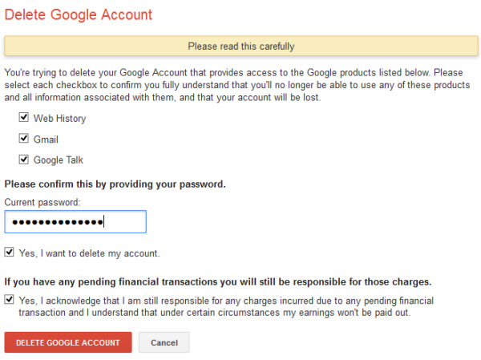<img class="aligncenter size-full wp-image-81283" alt="del_google 1" src="https://www.maketecheasier.com/assets/uploads/2013/09/del_google-1.jpg" />
4. Your Google account will be instantly deleted. There is no way to get your account back.


Yahoo
Yahoo is another popular network. If you are using Yahoo services, you may terminate your account by following the steps below:
1. Go to this link
2. Enter your password and the security code and press the “Terminate this account” button
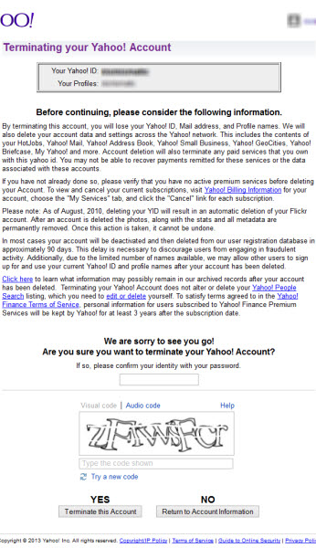<img class="aligncenter size-full wp-image-81286" alt="del_yahoo" src="https://www.maketecheasier.com/assets/uploads/2013/09/del_yahoo.jpg" />
3. This will disable your Yahoo account. You data will be deleted from Yahoo’s servers after 90 days.
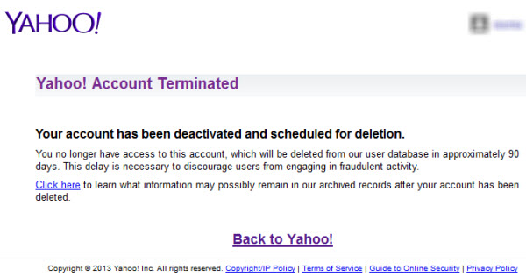

Twitter
Although you can mark your tweets as protected, if you do not intend to use your Twitter account again, it is a good idea to delete the account altogether.
To delete a Twitter account, do the following:
1. Go to this link
2. Click on the Deactivate button.
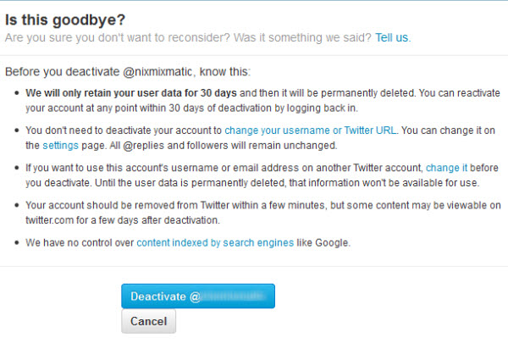<img class="aligncenter size-full wp-image-81291" alt="del_twitter" src="https://www.maketecheasier.com/assets/uploads/2013/09/del_twitter.jpg" />
3. Enter your password and click on the “Deactivate” button again
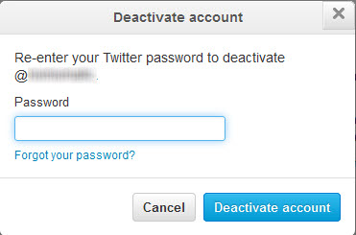<img class="aligncenter size-full wp-image-81289" alt="del_twitter 1" src="https://www.maketecheasier.com/assets/uploads/2013/09/del_twitter-1.jpg" />
4. Your account will be disabled and all data will be deleted from Twitter servers after 30 days


WordPress
If you have a WordPress.com account, unfortunately there is no way to delete the account. The workaround for this is to delete your sites in your WordPress.com account one by one and change the profile data to some random information. To delete a site from WordPress.com, go to the site’s dashboard and select “Delete Site” under Tools menu.
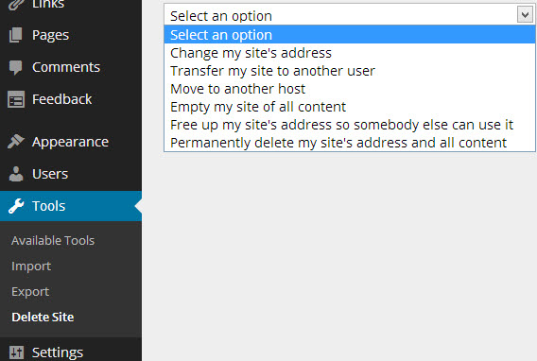

Microsoft
There are two Microsoft accounts. One is the Office 365 account which can be easily deleted by going to Office.com account settings. The second account is the Microsoft ID or formerly Windows Live or Hotmail or whatever they called it.
Deleting your Microsoft ID will delete your Outlook.com email, SkyDrive data and XBox Live account. To delete your Microsoft ID, follow the steps below:
1. Go to this link
2. Enter your password and click on the Next button
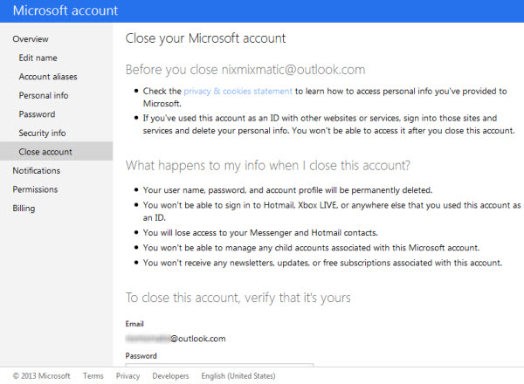<img class="aligncenter size-full wp-image-81297" alt="del_microsoft" src="https://www.maketecheasier.com/assets/uploads/2013/09/del_microsoft.jpg" />
3. Click on “Deactivate your Hotmail account” link
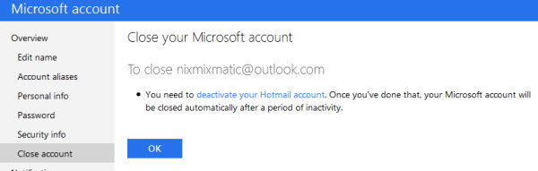<img class="aligncenter size-full wp-image-81295" alt="del_microsoft 1" src="https://www.maketecheasier.com/assets/uploads/2013/09/del_microsoft-1.jpg" />
4. Select a reason and press the “Deactivate account” button
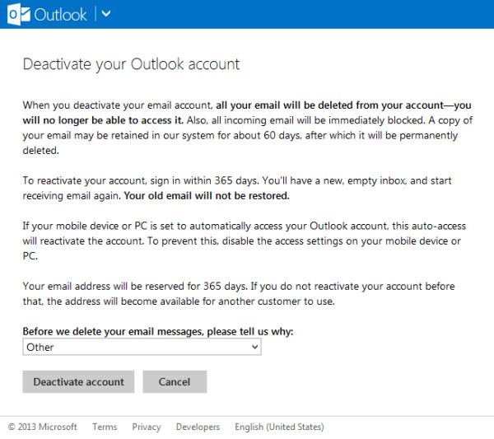<img class="aligncenter size-full wp-image-81296" alt="del_microsoft 2" src="https://www.maketecheasier.com/assets/uploads/2013/09/del_microsoft-2.jpg" />
5. This will delete your account and settings from Microsoft servers but your Microsoft ID will remain reserved for the next one year.

Skype
Although Skype is a Microsoft service, deleting a Skype account is very different from deleting a Microsoft account. You will need to go to your Skype account and change all the profile information to random one. Then change your primary email address associated with Skype to a fake one.
After you have removed your personal information from Skype profile, you will need to contact Skype support in order to delist yourself from Skype directory.

Flickr
Although Flickr is a Yahoo service, the Flickr profile and data can be deleted separately. To delete your Flickr account and data, do the following:
1. Go to this link
2. Press Ok – Next button
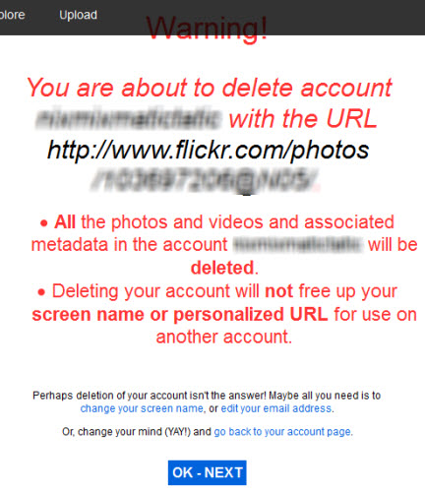<img class="aligncenter size-full wp-image-81302" alt="del_flickr" src="https://www.maketecheasier.com/assets/uploads/2013/09/del_flickr.jpg" />
3. Check the “Yes” checkbox and press the “Delete My Account” button
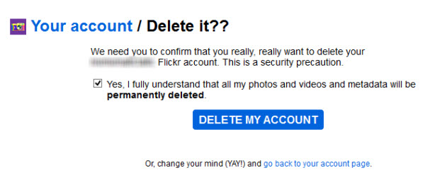

Deleting Other Accounts
For web services that are not listed above, Justdelete.me is a great site which gives you information on how to delete your data from different Internet services.
If you want to delete your personal information from the Internet automatically, you can use the DeleteMe service which is a paid service but automatically removes your personal information from most of the Internet properties.
Have you ever deleted any of your accounts from the Internet?

